**Before you travel don’t forget!!!**

**Mauritius:**

* **Passport:** must be valid for 6 months on arrival.
* **All-in-one Mauritius form:** must be completed before checking in for one’s flight: <https://safemauritius.govmu.org>
* **Tourism Levy:** All hotel guests are required to pay a tourist fee of Euro 3 per guest, aged 12 and older, per night as per the Mauritius Revenue Authority. This amount must be paid directly to the hotel upon check out.
* Airlines and authorities sometimes ask for travel documents: We recommend that clients carry copies (electronic or printed) of itinerary, vouchers and tickets and any other completed online forms.

**Seychelles:**

* **Passport:** Must be valid for the period of the intended stay until arrival back in the holder’s country of origin or residence.
* **Immigration form:** All travellers are required to complete immigration procedures when travelling to and from Seychelles. Please click <https://seychelles.govtas.com/> for access to the immigration forms. **There is a cost to passengers:**
  + Adults:
    - Standard processing times (24hrs before departure) – Euros 10
    - Premium processing (6hrs before departure) – Euros 30
    - Expedited processing (60 minutes before departure) – Euros 70
  + Children (12 yrs and under)
    - Standard processing times (24hrs) – Euros 10
    - Premium processing (6hrs) – Euros 30
    - Expedited processing (60 minutes) – Euros 30
* **Tourism Levy:** All hotel guests are required to pay a tourism environmental sustainability levy of SCR 100 (Approx R150) per guest per night at the time of check in. children under the age of 13 and Seychellois citizens are exempt.
* Airlines and authorities sometimes ask for travel documents: We recommend that clients carry copies (electronic or printed) of itinerary, vouchers and tickets and any other completed online forms.

**Maldives:**

* **Passport:** Must be valid for the period of the intended stay from check-in date.
* **Travel declaration online form:**
  + All travellers are required to complete the Maldives Traveller Declaration online form. This form must be completed 96 hours (4 days) before arrival in the Maldives.
  + There is no cost
  + Please click <https://imuga.immigration.gov.mv/traveller> to complete the form
* **Alcohol Ban:** There is a complete ban on importing alcohol in the Maldives. Duty-free purchases are no exception: they are confiscated upon arrival.
* **Tourism Taxes and or Levy:** These are included in the packages and are therefore pre-paid.
* Airlines and authorities sometimes ask for travel documents: We recommend that clients carry copies (electronic or printed) of itinerary, vouchers and tickets and any other completed online forms.

**Zanzibar:**

* **Passport:** must be valid for 6 months after the end of the client’s stay.
* **Mandatory Travel Insurance:**
  + All visitors are required to purchase the mandatory inbound insurance at a cost of $44 per person. This can only be obtained through the Zanzibar Insurance corporation via the website <https://visitzanzibar.go.tz>
  + It is recommended that clients still purchase their own fully comprehensive travel Insurance
  + There are various plans available:

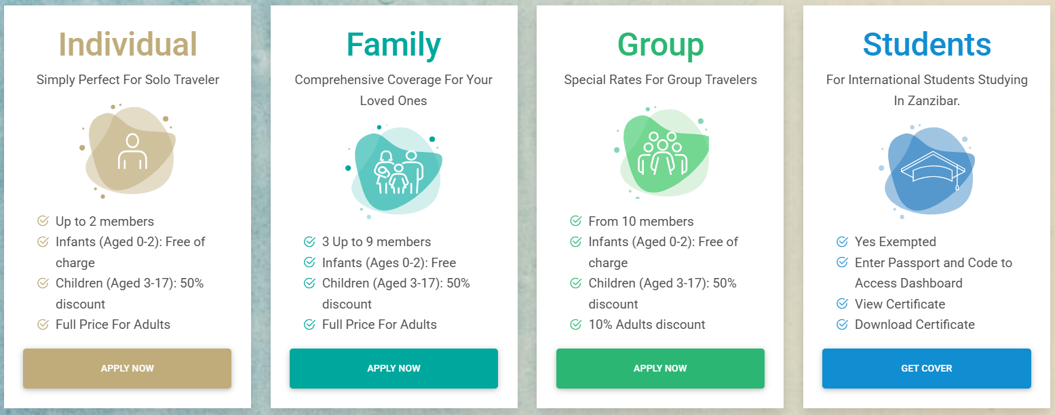

* Airlines will request proof of the mandatory insurance, accommodation and return air ticket at check in.
* **Completed Entry Form:** This document must be completed and is available at the immigration checkpoint. Some airlines may provide it on the plane.
* **Government Infrastructure Tax:** All hotel guests are required to pay an infrastructure tax of $5 per guest per night. This amount must be paid directly to the hotel upon check out.
* Airlines and authorities sometimes ask for travel documents: We recommend that clients carry copies (electronic or printed) of itinerary, vouchers and tickets and any other completed online forms.

**Thailand:**

* **Passport:** Must be valid for at least six months from the client’s arrival date.
* **The Thailand Digital Arrival Card:**
  + All travellers are required to complete The Thailand Digital Arrival Card.
  + This document must be completed 3 days before arrival in Thailand.
  + There is no cost.
  + Please click <https://tdac.immigration.go.th> to complete the online document.
* **Hotel levy for incidentals:**
  + It is common practice for hotel to request deposit of between 1000 (R500) – 3000 (R1,500) Thai Baht on arrival per day.
* Airlines and authorities sometimes ask for travel documents: We recommend that clients carry copies (electronic or printed) of itinerary, vouchers and tickets and any other completed online forms.

**Bali:**

* **Passport:** Must be valid for the period of the intended stay until arrival back in the holder’s country of origin or residence.
* **Forms:** 
  + On September 1, Indonesia introduced the ‘All Indonesia’ online declaration card, which all international travellers must fill out prior to arrival.
  + Arrivals at Soekarno-Hatta International Airport in Jakarta, Juanda International Airport in Surabaya and I Gusti Ngurah Rai Airport in Bali can complete the application at <https://allindonesia.imigrasi.go.id/>
  + The new system integrates immigration, customs and health forms into one application. This means international passengers no longer need to fill out separate electronic customs and health declarations.
* **Visa:**
  + South African passport holders can enter Bali without a visa for a 30-day stay, but they must obtain a Visa on Arrival (VoA). The VoA can be obtained online before travel via e-VoA <https://evisa.imigrasi.go.id/> or in person upon arrival at the airport. There is a cost of 35 USD
* Travellers will be asked for printed proof of accommodation, tickets, visas etc., please ensure you have these on hand

**And lastly, always travel with fully comprehensive travel insurance**